**Front-end Extended Bootcamp Training**

**Topic:** React Advanced (lifecycle methods, HOC and Hooks, conditional rendering, container, and component architecture, REDUX)

**Assignment:**

Incorporate the advance react topics in an existing react app with basic functionalities:

1. Convert ‘ItemDetails’ class component to function component.
2. Add 2 presentation components in ItemDetails. Define necessary attributes in the props / parent state to facilitate them –
   1. Using a simple icon & text html element – indicate if item is “Out of Stock!”
   2. Using a different icon and text html – indicate if item is eligible for “Fast track delivery”.
   3. Add the above 2 presentation components at the bottom of the item component (but inside).
3. Create hook for updating the product quantity for ItemDetails component.
4. Create hook for updating the product color for ItemDetails component (Add it as a new state attribute if not present)
5. Use HOC to render ‘StackItem’ component in App.js.
6. Use redux to add and remove items from cart.

**Existing react app:**



**How to run the react app:**

1. Extract the solution
2. Open VS code (visual studio code)
3. Open the src folder from the extracted folder in VS code
4. Open terminal in VS code
5. Navigation to the src folder path as follows:  
   ***C:\OldData\Downloads\my-app\my-app\src>***
6. Install node modules using below command  
   ***npm i***
7. Run the solution using the following command  
   ***npm start***
8. You will have the following view once the solution is running:  
   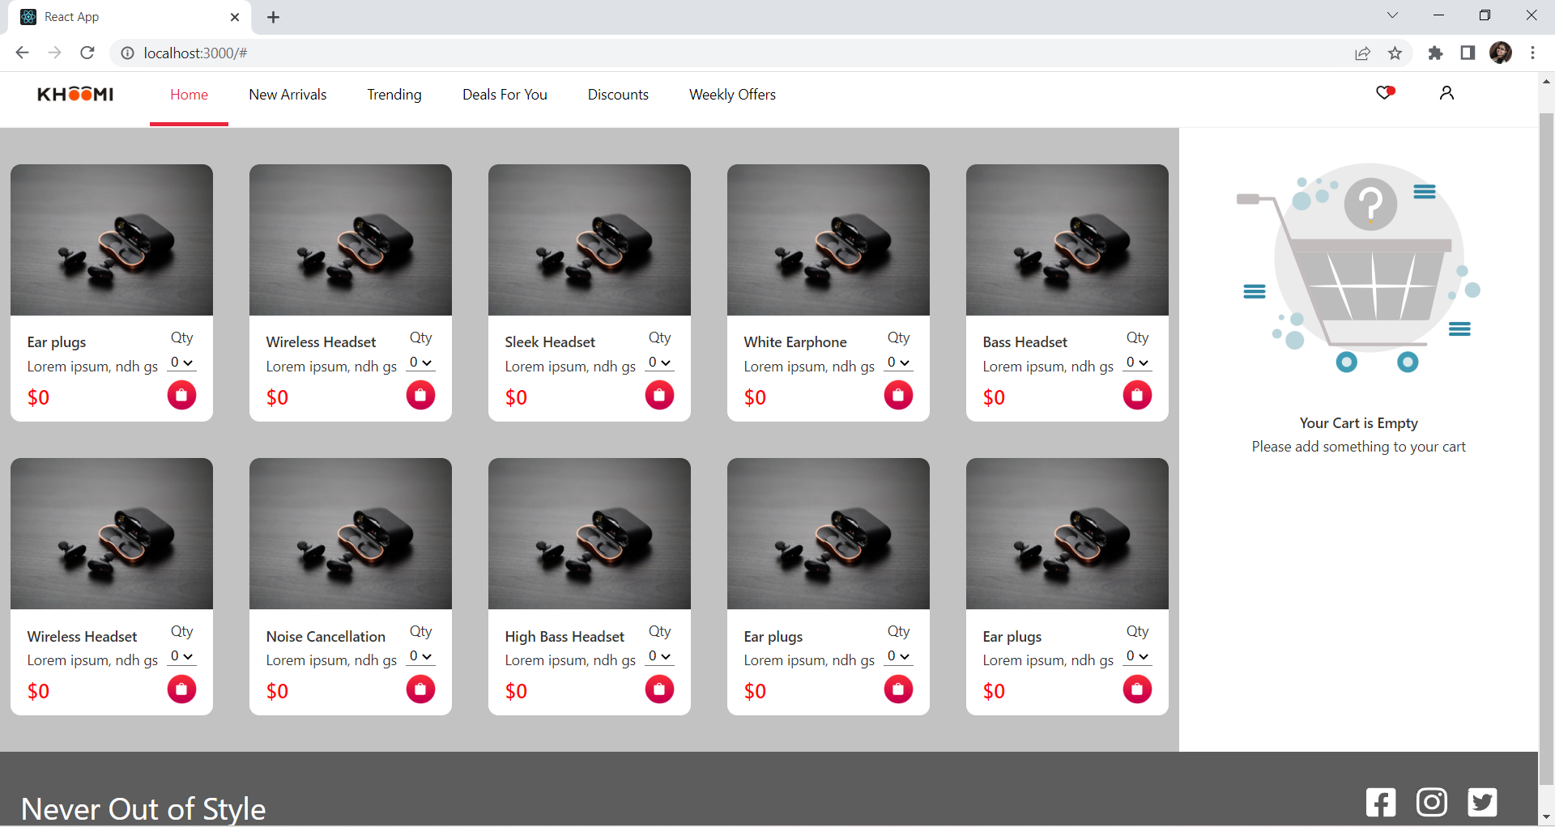

In case of doubts, please reach out to Mentors.

**Note:** Please upload assignment solutions without node_modules folder.